ELA Final Exam
***Do NOT write on this page***

Which definition describes the following Power Word?

- Support:

- to read between the lines; to figure out
- to back it up with evidence
- to show how things are alike
- to think about the future

- Analyze

- to retell the short version
- to show how things are alike
- to tell all about it with details
- to break down into parts (and the whole)

- Formulate

- to judge; to assign a value
- to show how things are alike
- to build or create; to make or come up with
- to tell how or why

- Contrast

- to show how things are alike
- to think about the future
- to retell the short version
- to examine the differences

- Evaluate

- to outline or list in steps
- to judge; to assign a value
- to build or create; to make or come up with
- to examine the differences

- Trace

- to outline or list in steps
- to back it up with evidence
- to build or create; to make or come up with
- to tell how or why

- Infer

- to outline or list in steps
- to examine the differences
- to read between the lines; to figure out
- to tell all about it with details

- Summarize

- to retell the short version
- to tell how or why
- to back it up with evidence
- to judge; to assign a value

- Compare

- to judge; to assign a value
- to show how things are alike
- to think about the future
- to retell the short version

- Describe

- to show how things are alike
- to examine the differences
- to tell all about it with details
- to judge; to assign a value

- Explain

- to tell all about it with details
- to retell the short version
- to judge; to assign a value
- to tell how or why

- Predict

- to think about the future
- to tell how or why
- to show how things are alike
- to judge; to assign a value

What is the author’s purpose?

- The author is giving facts, directions, or information. It is often called an expository writing that shows or explains facts. Examples; biography, news reports, a note to a friend, an essay, scripts for documentaries.
- Persuade
- Inform
- Entertain
- The author is telling a story to make you feel a certain way (happy, sad, curious, scared … ). Narratives (stories) are all written to entertain. They have a beginning, middle, and an end. The story may have a lesson, but the author’s main purpose is to entertain. Examples; fiction short stories and novels, poetry, narrative essays, scripts for television shows or movies.
- Persuade
- Inform
- Entertain
- The author is trying to get you to feel a certain way. It attempts to influence the reader and usually makes an argument. Examples; political speeches, advertisements, a cover letter to a resume, an essay urging readers to recycle.
- Persuade
- Inform
- Entertain

What is the narrative point of view?

- The narrator has unlimited knowledge and can describe every character’s thoughts and interpret their behaviors.

- Third Person Omniscient
- First Person
- Second Person
- Third Person Objective

- The narrator is a character within the story recounts his or her own experiences or impressions.

- First Person
- Second Person
- Third Person Limited
- Third Person Omniscient

- The narrator is speaking directly to the reader or tells the story from the perspective of “you”.

- Third Person Limited
- First Person
- Second Person
- Third Person Objective

- The narrator remains a detached observer, telling only the story’s actions and dialogue.

- First Person
- Second Person
- Third Person Limited
- Third Person Objective

- The narrator tells the story from the viewpoint of only one character in the story.

- First Person
- Second Person
- Third Person Limited
- Third Person Omniscient

What does IRACE stand for?

- I –

- Illustrate
- Indent
- Infer
- Inform

- R –

- Reread
- Restate
- Retrace
- Retract

- A –

- Acknowledge
- Analogy
- Answer
- Apply

- C –

- Cite
- Consider
- Construct
- Correlate

- E –

- Evaluate
- Examine
- Exempt
- Explain

What is the text structure being used?

- A conflict is presented and resolved.

- Compare and Contrast
- Description
- Problem and Solution
- Sequence

- A specific person, place, or thing is being described.

- Compare and Contrast
- Description
- Problem and Solution
- Sequence

- Something happens as a direct result of something else.

- Cause and Effect
- Compare and Contrast
- Description
- Sequence

- Specific time or order of events is being examined.

- Cause and Effect
- Description
- Problem and Solution
- Sequence

- Two or more items are being examined to find what is similar and what is different.

- Compare and Contrast
- Description
- Problem and Solution
- Sequence

Which part of a summary does the following describe?

- 1 or 2 words that identify the subject (person, place, thing, or idea) of a text.

- Key Points
- Main Idea
- Supporting Details
- Topic

- Relates directly to and clarifies the topic, explains specifically what is being examined relating to the topic of a text.

- Key Points
- Main Idea
- Topic
- Supporting Details

- Supports the main idea by providing evidence to back it up.

- Key Points
- Main Idea
- Topic
- Supporting Details

What is the literary device?

- an exaggeration

- Alliteration
- Idiom
- Hyperbole
- Simile

- compares two things using like or as

- Alliteration
- Onomatopoeia
- Personification
- Simile
- compares two things where one is the other

- Hyperbole
- Idiom
- Metaphor
- Personification

- repetition of consonant sounds at the beginning of words

- Alliteration
- Onomatopoeia
- Metaphor
- Simile

- this is where animals or inanimate objects are given human qualities

- Idiom
- Metaphor
- Personification
- Simile

- type of phrase where the meanings cannot be inferred by the literal meaning of the words

- Alliteration
- Hyperbole
- Idiom
- Personification

- words that represent sounds

- Hyperbole
- Idiom
- Metaphor
- Onomatopoeia

Final Exam Answer Key:

- B
- D
- C
- D
- B
- A
- C
- A
- B
- C
- D
- A
- B
- C
- A
- A
- A
- C
- D
- C
- B
- B
- C
- A
- D
- C
- B
- A
- D
- A
- D
- B
- A
- B
- D
- C
- A
- C
- C
- D

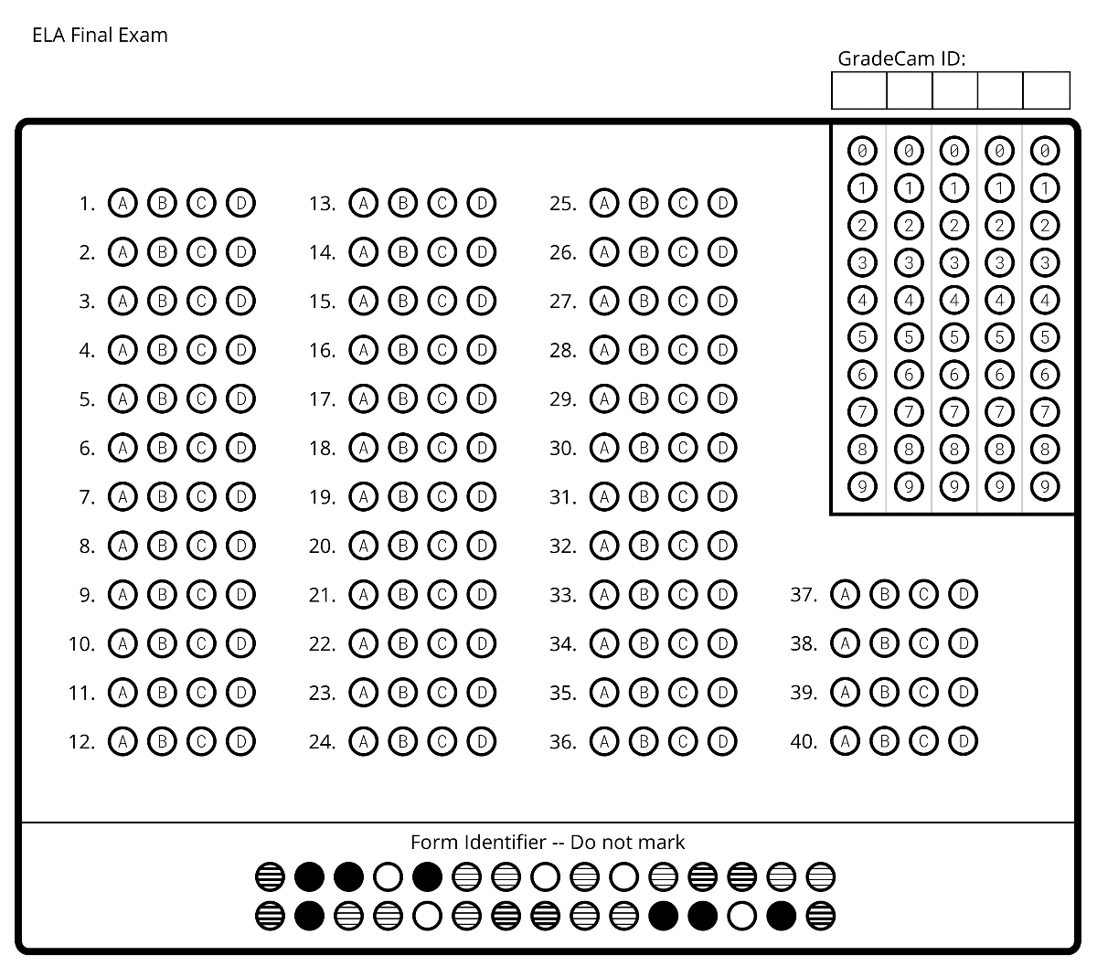
Name:_______________________________________
Date:________________________________________
Period:______________________________________

Name:_______________________________________
Date:________________________________________
Period:______________________________________

